***ASSIGNMENT ON***

***HOUGH TRANSFORM***

* CVG LAB 2020-21
* Saloni Shah
* 01FE18BCS183

The Hough transform can be used to detect lines circles or The Hough transform (HT) can be used to detect lines, circles or other parametric curves. The goal is to find the location of lines in images. Hough transform can detect lines, circles and other structures if their parametric equation is known. It can give robust detection under noise and partial occlusion It can give robust detection under noise and partial occlusion.

Steps to find Hough Tranform:

**Step 1: Find Canny edges of the image.**

The Process of Canny edge detection algorithm can be broken down to 5 different steps:

* Compute image derivatives, Gx and Gy.

Smoothing with a Gaussian Filter.

Use derivative kernels [1 -1]

* Compute edge detection: tan(alpha) = Gy/Gx.
* Edge point is the local maxima in edge detection.

Eg: Zero crossing. (To get an edge with width 1)

* Use only edge points with gradient above the threshold.
* Hysteresis: Edge linking with two thresholds.

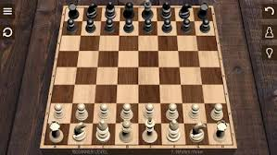 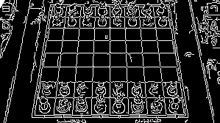

Original Image Canny Edge detection output

**Step 2:**

Result of canny edge detection would give a matrix with values 0 and 255 where 0 represents not an edge point and 255 represents an edge point.

Generate a range of values for theta. (In proposed solution, I have considered values 0 – 180).

The maximum value for rho is sqrt(x*x + y *y).

**Step 3:**

Construct a matrix of size ( 2 * rho, values of theta). Initialise the values to 0.

Algorithm:

For all x in img.shape[0]

For all y in img.shape[1]

Check if it is a edge point, i.e, equal to 255

For all theta values

Rho = x * cos(theta) + y * sin(theta)

Increment the value in matrix constructed in previous step at corressponding rho and theta.

End

End

End

End

**Step 4:**

Define some threshold. Consider the indices of the matrix with values above threshold. (In proposed solution, threshold is considered as 100).

For all the edge values, find points to construct a line using the equations- X = x0 + r * cos(t)

Y = y0 + r * sin(t)

Construct lines and plot image.

**Result –**

